7th February 2025

Dear parents and carers,

Year 2 have just started learning about multiplication (times tables). We will be learning the following times tables this year: 2s, 5s, and 10s. Children who are fluent in these will progress to 3 times tables before starting year 3.

Please use the resource pack to support your child to learn the concepts behind multiplication and to practise first with counting in tens. These items can be taken out of your child’s book bag for home use.

We recommend the Times Table Rock Stars app to develop fluency. You will find your child’s login details for the app in their reading record. It is the same as one as Numbots.

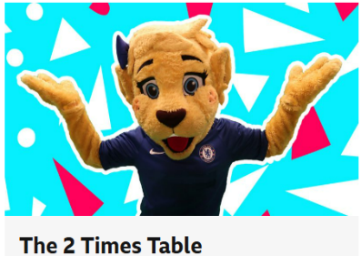
Other useful resources can be found on BBC Teach, Supermovers KS1 Maths website page: 

Our maths scheme, White Rose, also has some useful videos to help understand multiplication in Key Stage 1. The videos are less than 10 minutes long.

Equal Groups Video: https://vimeo.com/775753306
Make Equal Groups Video: https://vimeo.com/775753393
Add Equal Groups Video: https://vimeo.com/775753518
Introduce the Multiplication Sign: https://vimeo.com/775753693
Multiplication Sentences: https://vimeo.com/775753693

A copy of this letter will be posted on the school website. Please look in the Spring Term folder on the Willow Class page.

The Willow Class Team
Ms Morison, Mrs Barton and Mrs Patel

