Meet our Mindmate Ambassadors


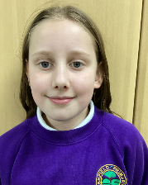
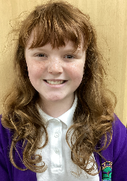
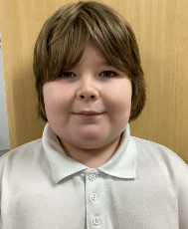
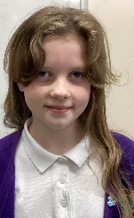
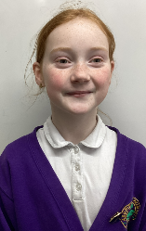
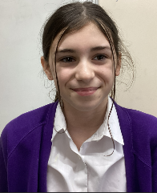

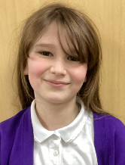

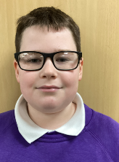

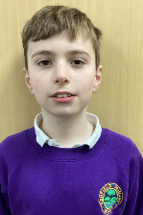

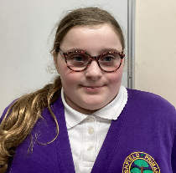

We have an amazing team of Y6 Mindmate Ambassadors at Ashfield and they are very excited to begin their new role in school. They have lots of ideas around supporting Mental Health and Wellbeing for our pupils. The role of a Mindmate Ambassador is to raise awareness of Mental Health and support pupils in school with strategies to look after their wellbeing. Our fantastic team of ambassadors successfully applied for the role and will be making a huge difference to our school. Well done everyone!

Children’s Mental Health Week 2025
Week Beginning 3rd February 2025

Children’s Mental Health week is coming up in school and we are all excited to learn more about our Mental Health and to spend time during this important week exploring activities and learning new skills that support our Wellbeing. Taking feedback from each class, we have created an exciting timetable of events over the week for our children to explore.

Please see the next page for the timetable of the week. On Monday 3rd February the Mindmate Ambassadors would like to run a bun sale to raise money for a new Mindmate Ambassador bench and friendship stop for the playground. If you can kindly donate some buns for our sale, we would be very grateful. Please bring buns/cakes/biscuits into school on Monday 3rd Feb and the sale will be straight after school at a price of 50p per item.
Thank you

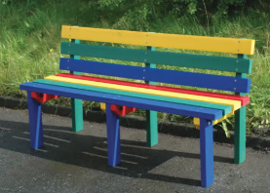

 | Information for parents | Happening in school
Monday | Children can wear comfy clothes to school today.  Reading for pleasure – children can bring in a book from home.  Bake sale after school to raise money for a Mindmate Ambassadors Bench on the playground.  Mindmate Ambassadors meet and greet on the playground. | Special assembly  Supermovers!  Mindmate Ambassador Mindfullness session in each class.
Tuesday | Reading for pleasure – children can bring in a book from home. Mindmate Ambassadors meet and greet on the playground. | Supermovers!  Design your own Worry Monster competition
Wednesday | Reading for pleasure – children can bring in a book from home.  Mindmate Ambassadors meet and greet on the playground. | Supermoovers!  Know yourself Art Activity
Thursday | Bring your wellies day – nature walk around the school grounds.  Reading for pleasure – children can bring in a book from home.  Mindmate Ambassadors meet and greet on the playground. | Supermoovers!  Yoga with another class and a nature walk around our school grounds.
\Friday | Reading for pleasure – children can bring in a book from home.  Mindmate Ambassadors meet and greet on the playground. | Supermoovers!  You choose afternoon: Each class to choose a craft, book, boardgame, relaxation activity.

We are very much looking forward to this important week to raise the profile of positive Mental Health and Wellbeing for our pupils.

Thank you for your continuing support.

Mrs Davison

