

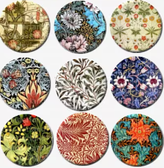
Biography (1834-1896)
William Morris is one of the most influential designers of the 19th Century. His worked included wallpaper design and print, furniture , stained glass windows, tiles and tapestries.
His career in designing started when he decorated his own house in London. William Morris, who was also an environmental campaigner, created designs of floral patterns (patterns inspired by flowers and plants) which were repeated many times by block printing.
What William Morris did was to make designs of floral patterns (patterns inspired by flowers and plants) that could be repeated many times by block printing techniques on large pieces of paper to make patterned wallpaper.
William Morris’s patterns are still popular today. They feature on greetings cards, bags, soft furnishings and even umbrellas!

Key Vocabulary
Lino Printing
Block Repeated
Pattern
Symmetrical
Mirrored
Pattern
Geometric
Pattern
Motif
Reflection
Half Drop Pattern
Roller
Decorative

KNOWLEDGE ORGANISER

1884
Founded the Socialist League

Significant Works
Application of Knowledge
Make prints and patterns using everyday natural and man-made objects, based on cultural influences in the style of William Morris.
Talk about repeated block pattern, mirrored /symmetrical and half drop patterns. Use a range of materials to create a more complex printing block using more than one colour. Talk about and evaluate a wide range of complex patterns .Create complex surface textures by mixing and combining techniques.
Links
https://kids.kiddle.co/William_Morris
https://thekidshouldseethis.com/post/block-printing-william-morris-wallpaper
https://www.tate.org.uk/art/artists/william-morris-388



