

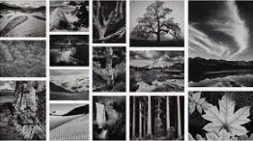
Biography (1902-1984)
Ansel Adams was a world famous Californian photographer. His photography has greatly influenced the National Park Service. It has also helped in the conservation of American nature.
Ansel Adams was born in San Francisco in 1902. He grew up near the Golden Gates Bridge. He was injured badly in the 1906 earthquake and as a result of this, was bullied at school. He was withdrawn from school and taught at home by his aunt and father.
During this time, Adams joined the Sierra Club (a group that hiked in the Sierra Mountains, Nevada). He discovered how much he enjoyed nature and spent time in the summer taking photographs in the Yosemite National Park. His photography influenced the founding of the American National parks.

Key Vocabulary
Tone
Dark
Light
Shadow
Chiaroscuro
Perspective
Bird’s Eye View
Three Dimensional
Landscape
Grandiose
Majestic
Monumental
Atmospheric
Charcoal
Graphite

KNOWLEDGE ORGANISER

1946
Californian School of Fine Arts founded
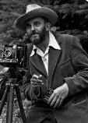

Significant Works
Application of Knowledge
Cross-hatching: Layers of lines are drawn in several directions. The more layers are used, the darker the area becomes.
Blending: Different pressures are used when shading to achieve light, medium and dark tones. Using your finger tip to gently blend and smooth the graphite achieves a smooth blend; a rubber can also be used to blend and add highlights.
Stippling: Layers of dots are built up to give the appearance of light, medium and dark tones within an object or drawing

Links
https://kids.britannica.com/students/article/Ansel-Adams/272708
https://www.anseladams.com/
https://www.youtube.com/watch?v=rX3oKJmlTpI

