

Key Vocabulary
Abstract

Colour Mixing

Primary Colours

Secondary Colours

Concentric Circles

Tints

Shades
Biography (1866-1944)
Wassily Kandinsky was born in Russia, in 1866.
When he grew up, he worked as a teacher at a
university but it didn’t make him happy.
When he was 30, he left his job and went to art
school. He found art school easy and was very good at his studies.
Kandinsky thought a lot about what colours mean and how they make people feel. He believed that colours had a soul.
He was the first painter to stop painting pictures of things and instead paint just using colours and shapes. He believed that this let him paint honestly about his feelings.
Often Kandinsky would listen to music while he painted and try to paint what he heard.

KNOWLEDGE ORGANISER
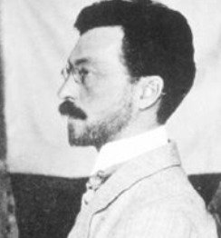

Significant Works
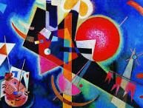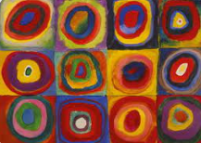
1944
Kandinsky dies leaving a legacy to abstract art.

