

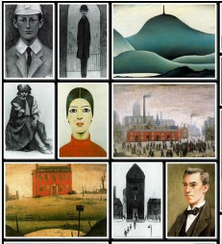
Biography (1887-1976)
Laurence Stephen Lowry was born in Stretford, Manchester and lived in Manchester and Salford all his life.
He painted the everyday people and places around where he lived. He was famous for his industrial landscapes, often showing mills and factories.
He was famous for his match stick figures. There was even a song about him ‘Matchstalk men and Matchstalk cats and dogs’.
He was the official artist for the Queen’s perspective coronation in 1953
He was a big Manchester City FC fan. Find out more about Lowry by reading …..
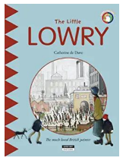

Key Vocabulary

Naïve
Simplified
Stylised
Matchstick
Perspective
Drab
Cityscape
Urban
Industrial
Mills
Factories
Salford
Manchester

KNOWLEDGE ORGANISER

1976
Dies from pneumonia, Glossop, Derbyshire
Links https://issuu.com/the_lowry/docs/teachers_resource_pack
https://www.tate.org.uk/art/artists/l-s-lowry-1533
https://www.tate.org.uk/art/artists/l-s-lowry-1533/how-paint-lowry

Significant Works


