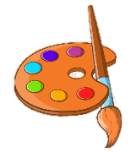

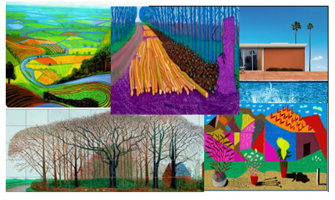
Biography (1937-)
Born in Bradford, Yorkshire, David Hockney attended Bradford College of Art and progressed to the Royal College of Art in London. His talent was recognised in London and he was awarded the Royal College of Art gold medal iin 1962 for his mastery as a draughtsman. He achieved his first solo exhibition a u year later.
Hockney moved to California soon after and has lived between the UK and USA for most of his life. Many of his works of art are exhibited at Salts Mill, Saltaire. It is open to the public free of charge.
Hockey is still painting and trying lots of new experiments with art. Some of his most recent work includes painting on iPads.
Hockney was appointed the Order of Merit in 2012 by the Queen for his services to art. He turned down an OBE in the 1990s because he did not want ‘all the fuss’.

Key Vocabulary

Landscape
Pop Art
Cubism
Fauvism
Realistic
Large Scale
Perspective
Bright
Lurid
iPad
Computer Graphics
Posca Pens

KNOWLEDGE ORGANISER

2020
Lives in Normandy, during pandemic
Links
https://www.tate.org.uk/kids/explore/who-is/who-david-hockney
https://kids.kiddle.co/David_Hockney
https://www.arthistorykids.com/blog/262

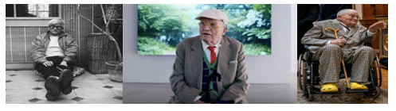

Significant Works

