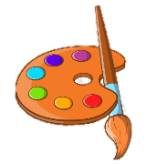

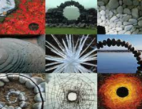
Biography (1956-)
Andy Goldsworthy grew up outside of Leeds. From the age of 13 he worked on farms as a labourer. He studied fine art at Bradford College of Art from 1974 to 1975 and at Preston Polytechnic (now the University of Central Lancashire).
After leaving college, Andy lived in Yorkshire, Cumbria and Scotland. Andy makes sculptures with natural materials on sites in the UK and around the world. He has made them in forests, fields, cities, lakes and fields. They are known as land art.
The materials used in Goldsworthy’s art often include brightly coloured flowers, icicles, mud, pinecones, snow, stone, twings and thorns. His art is often ephemeral (temporary) so photography plays an important part in his art.
In 2007, Goldsworthy was commisioned to build outdoor sculptures in the grounds of the Yorkshire Sculpture Park, Wakefield. Outclosure and Peter’s Fold have been built using dry stone walling.

Key Vocabulary

Land Art
Landscape
Ephemeral
Temporary
Sculpture
Installation
Natural Materials
Purity
Simplicity
Beauty
Environment
Rock Balancing

KNOWLEDGE ORGANISER

2007-2008
Installations at YSP, Wakefield
Links
https://ysp.org.uk/art-outdoors/outclosure
https://kids.kiddle.co/Andy_Goldsworthy
https://www.tate.org.uk/art/artists/andy-goldsworthy-7274/andy-goldsworthy-share-connection-stone

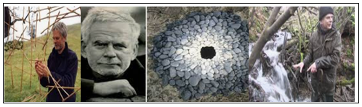

Significant Works

