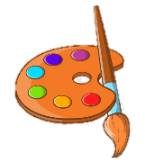

Biography (1903-1975)
Barbara was born in Wakefield in Yorkshire. Her earliest memories were from driving through the countryside with her family. She never forgot the shapes made by the roads, hills and fields and they inspired her to make some amazing artwork.
She studied at Leeds School of Art with Henry Moore, who became a life-long friend.
Many of Barbara Hepworth's sculptures were abstract. They were made of wood, stone and bronze. Barbara said her work was a way of 'holding a beautiful thought’
Hepworth wanted to create art that was calm, that people could enjoy looking at and wouldn’t make them feel uncomfortable or anxious. She began to make sculptures and drawings that were inspired by the landscape and nature around her. She lived most of her life in St Ives, Cornwall where she had a studio.

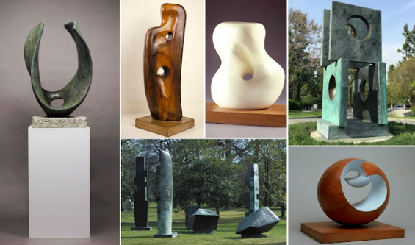
Key Vocabulary
Abstract

Sculpture

Sculptor

Bronze

Marble

Form

3 dimensional

Public art works
KNOWLEDGE ORGANISER

1975
Dies in an accidental fire at the studio.
Significant Works


