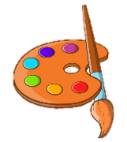
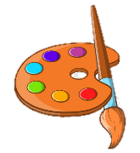
ART
KNOWLEDGE ORGANISER
Overview  EYFS LEARNING IN |  |  |  |  | Being Imaginative |  |  | Key Vocabulary  Art  Design  Colour  Texture  Creative  Emotions  Tools  Imagination  Five Senses
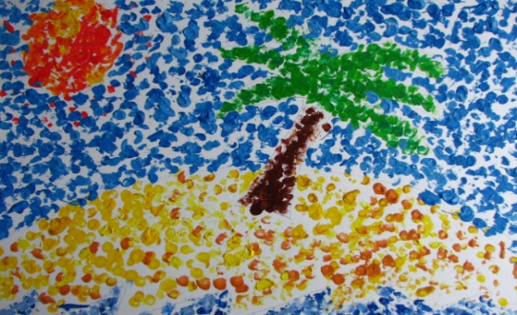  Art and Design  -In Art and Design, we learn to be creative, using our imaginations to show feelings and ideas.  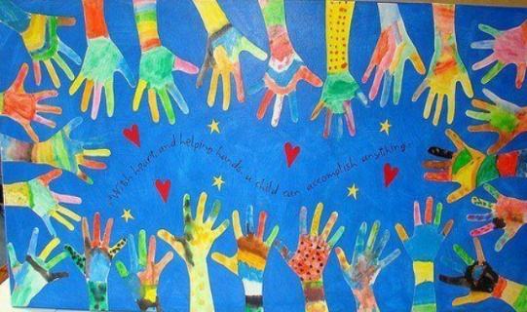  -Art can be anything that we can sense: things we can see, hear, feel, smell, or taste.  -Designing is about thinking up ideas to solve problems and to get the result that we want.  In EYFS, early Artand Design is found in the ‘Expressive Arts and Design’ learning area. |  |  |  |  | Imagination  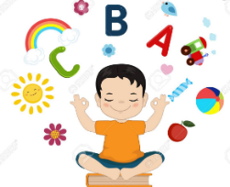  Using your imagination is about having new ideas! When using our imaginations, we create things that we find fun and interesting. We can also show different emotions (how we feel) and create new things that are not real.  Designing  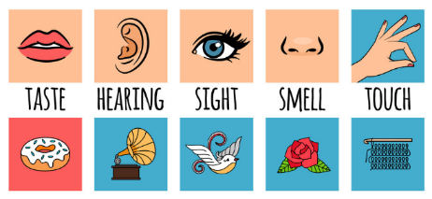  When we are designing, we are thinking about ways that we can get a result (a finished piece of work) that we want or need. Some questions that designers might ask.-How can we fix problems in our world?-What things look/sound/feel good together?We should also think about what it is for (purpose) and who will use it.  The Five Senses  Our senses work together to help us to take in what is going on around us. When we create art, we need to think about what it does to each of our senses.
Exploring and Using Media and Materials
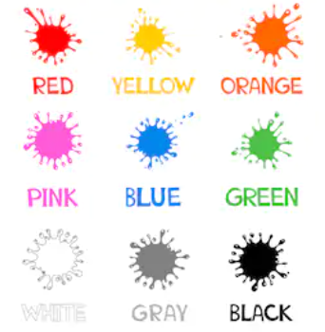 | Mixing Colours  Sub-Area: Exploring and Using Media and Materials | Colours can be mixed together to make other colours.  -The three primary colours are blue, red and yellow.  Blue + Yellow = GreenYellow + Red = Orange  Red + Blue = Purple Black + White = Grey  White + Red = PinkRed + Green = Brown  -Adding more or less of colours makes different shades.
 |  |  |  |  | Different Art Forms
 |  |  |  |  | 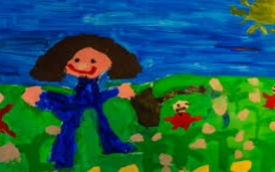 | Drawing/Painting | Drawing and painting are types of visual art (art that can be seen). Lines are used to create shapes and objects. By mixing colours, we can create new shades.
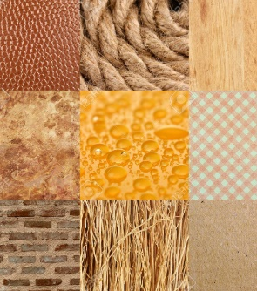 | Textures  Sub-Area: Exploring and Using Media and Materials | Texture is how something feels to touch.  We can use adjectives to describe different textures:  Bumpy - Lego Rough - Sandpaper Hard - Wall  Fuzzy -Teddy Bear Smooth - Plastic Soft - Pillow  Lumpy - Bean Bag Prickly – Thorns Shiny – Car  Different textures are useful for different products. |  |  | 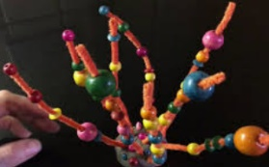 | Sculpture | Sculpture is another type of visual art. Sculptures are made using objects (not drawn onto paper). The objects can be cut, carved, stuck or arranged in different ways.
 |  |  |  |  | 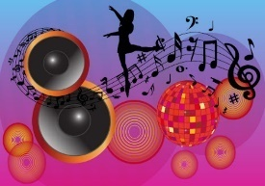 | Music and Dance | Music is a type of art that can be heard – it is about different sounds and sound patterns. Dance is how we can use our bodies to move to music. Dancing can be performed in patterns (dance sequences).
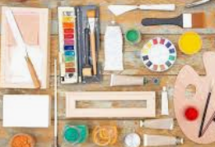 | Using Tools  Sub-Area: Exploring and Using Media and Materials | Tools are objects that help us to change things. They do many different jobs. Examples of art toolsand materials are: Pencils,Pens,Paint, Crayons, Brushe,sDropper,sRollers,Scissors , Glue Spreaders, Hole Punches, |  |  |  | Music and Dance
 |  |  |  |  | 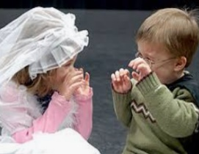 | Photography and Role-Play | Photography allows us to capture the art that we see in the world around us. We can edit the photographs in different ways. Role-play is when we act as another person or character (real or imagined).

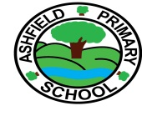
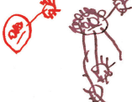
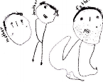
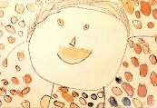
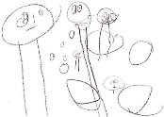
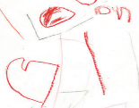
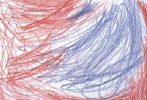
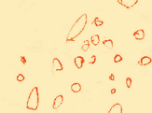
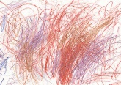
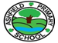
2.Partially- ControlledScribble
8.Large Head Partial Stick Man
6.’Head – Feet Symbols
5.’Tadpoles’
8.Large Head Stick Man
9.Figure Schema
4.Controlled Scribble
3.Controlled Scribble
1.Random scribble
Developmental Stages

