
Art and Design Long Term Plan - Upper Key Stage 2

Year 5
 | Autumn Area of Experience | Autumn Technique | Spring Area of Experience | Spring Technique | Summer Area of Experience | Summer Technique
 | Form | Sculpture | Tone | Drawing | Colour | Painting
Artists |  |  | Ansell Adams (photographer) |  | Hockney
Cross Curricular | The Art of the Kingdom of Benin |  | Rivers |  | Mountains
 | 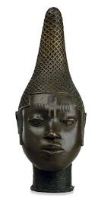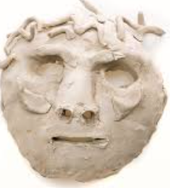 |  | 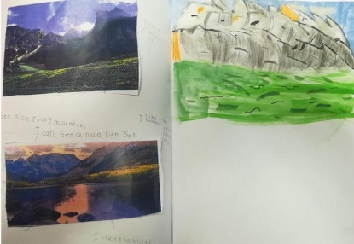  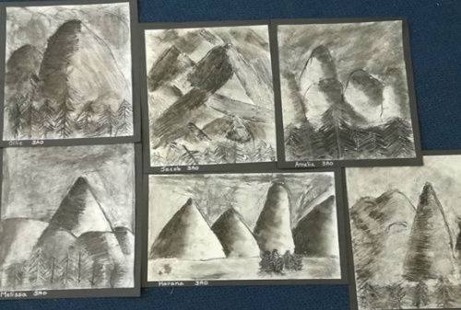 |  | 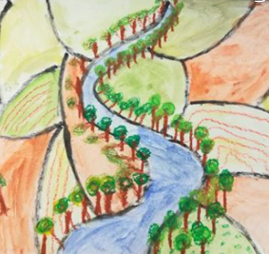  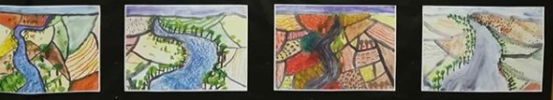
Year 6
 | Autumn Area of Experience | Autumn Technique | Spring Area of Experience | Spring Technique | Summer Area of Experience | Summer Technique
 | Line | Drawing | Texture | Weaving | Pattern | Watercolours
Artists | Lowry |  |  |  | William Morris
Cross Curricular | Otley Industrial Townscapes |  | Fairtrade Routes (Mayan) |  | Crime and Punishment - Victorian
 | 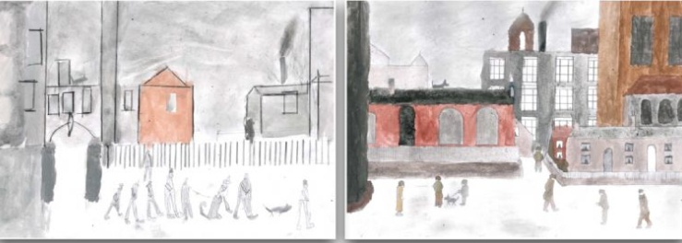 |  | 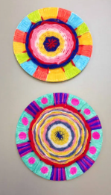 |  | 

