
Art and Design Long Term Plan - Lower KS2

Year 3
 | Autumn Area of Experience | Autumn Technique | Spring Area of Experience | Spring Technique | Summer Area of Experience | Summer Technique
 | Tone | Stonehenge  Silhouettes | Line | Multimedia  Portraits | Texture | Textile Collages
Artists |  |  | Gustav Klimt |  | Jeannie Baker
Cross Curricular | Stoneage |  | Egyptians (King Tut Portraits) |  | Geography (Otley Field Study Work)
 | 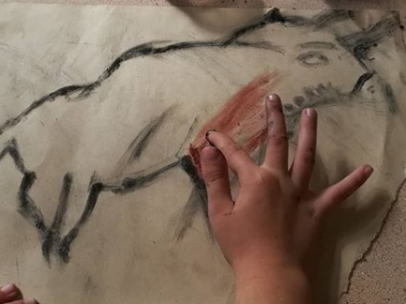  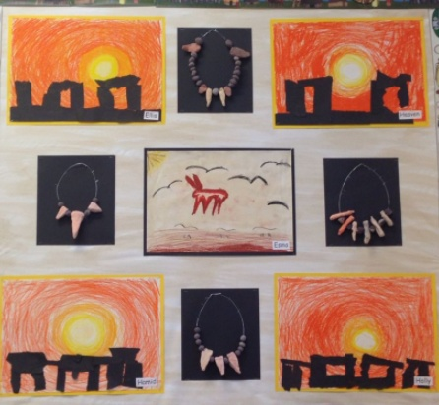 |  | 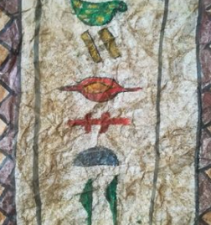  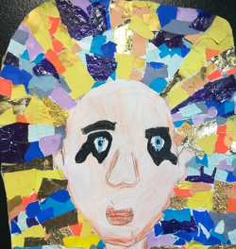 |  | 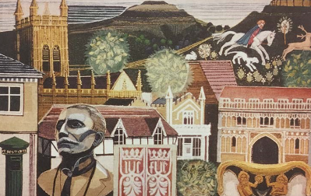
Year 4
 | Autumn Area of Experience | Autumn Technique | Spring Area of Experience | Spring Technique | Summer Area of Experience | Summer Technique
 | Form | Sculpture | Pattern | Mosaics | Colour | Painting Techniques
Artists | Andy Goldsworthy Land Art |  |  |  | Cressida Cowell Illustrator
Cross Curricular | Geography (The Chevin) |  | Romans |  | Vikings
 | 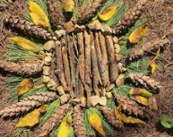  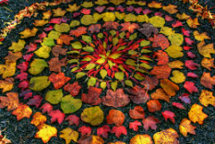 |  | 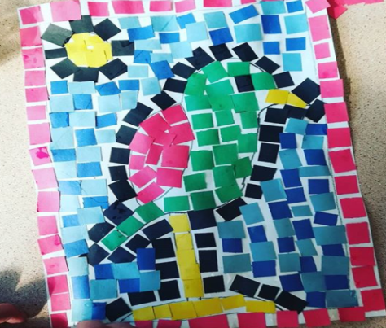  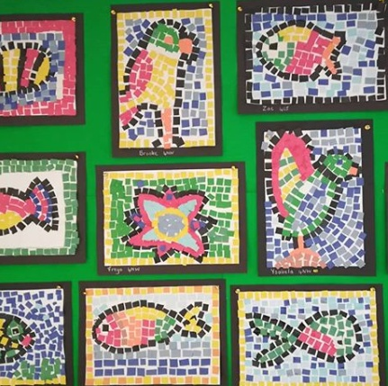 |  | 

