
Art and Design Long Term Plan - Key Stage 1

Year 1
 | Autumn Area of Experience | Autumn Technique | Spring Area of Experience | Spring Technique | Summer Area of Experience | Summer Technique
 | Texture | Collage | Colour | Painting | Pattern | Printing  Painting techniques
Artists | Eric Carle (Illustrator) |  | Kandinsky |  | Andy Warhol/ Bridget Riley
Cross Curricular | Science (Animals in the Local Area) |  | Music (In the Groove) |  | History (Seaside Holidays of the Past)
 | 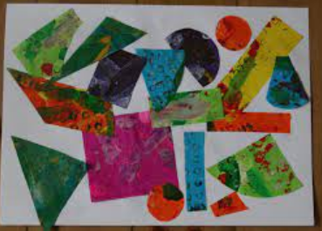  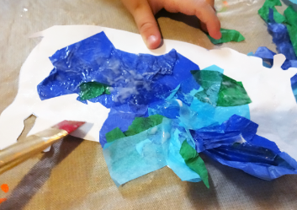 |  | 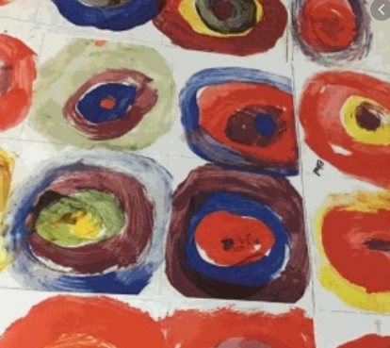 |  | 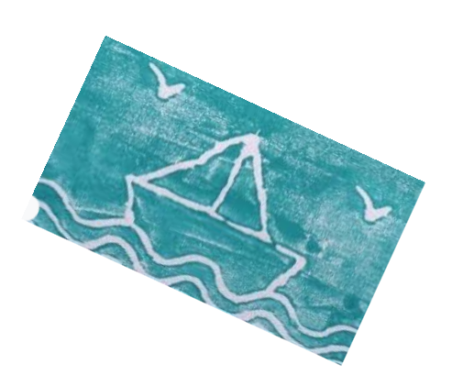
Year 2
 | Autumn Area of Experience | Autumn Technique | Spring Area of Experience | Spring Technique | Summer Area of Experience | Summer Technique
 | Texture | Weaving | Line | Drawing | Tone & form | Shading  Clay modelling
Artists | Andy Goldsworthy (land art) |  |  |  | Barbara Hepworth
Cross Curricular | Science (Materials) |  | History (Great Fire of London) |  | Weather & Outdoors
 | 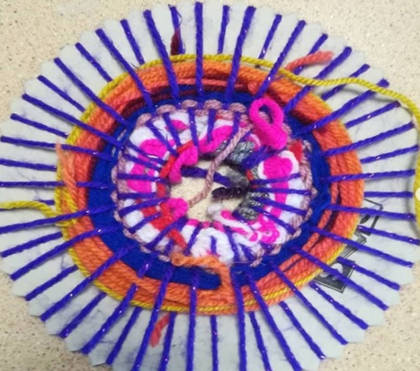  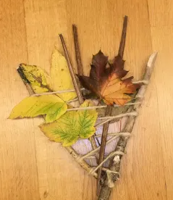 |  | 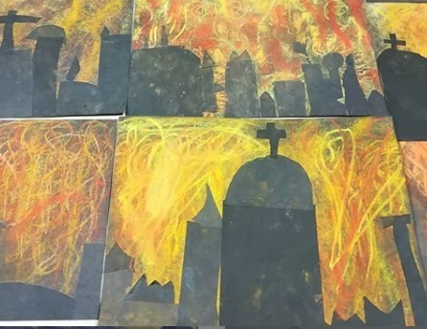  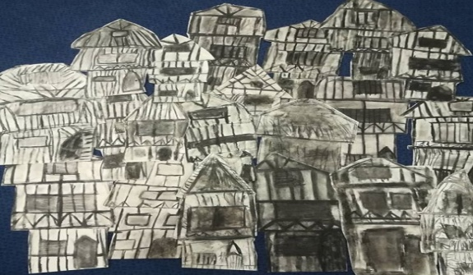 |  | 

