P.E:
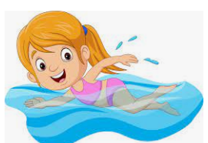
As an athlete I can:

Swim 25m confidently showing a range of strokes.

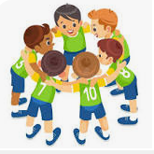
Perform successfully within a team showing excellent speaking and listening skills.


Have a positive attitude towards physical activity.


Understand and demonstrate how to look after my body physically and mentally.

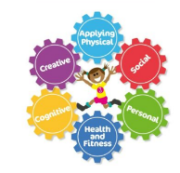
Apply my fundamental movement skills to game scenarios.

