Ashfield Primary School Dyslexia Policy
Agreed by Teaching and Learning Committee 26/01/2023
Review Spring Term 2026

This policy is to supplement the SEND policy and considers children with a specific difficulty in literacy (dyslexia).
Ashfield Primary School is committed to ensuring that all children, irrespective of disability or learning difficulty, are able to access appropriate inclusive and differentiated teaching approaches. The aim is always to raise achievement.
This policy reflects our duty under the New Code of Practice for Special Educational Needs (20) and under the Equality Act (2010)
Reading and writing has a key role in accessing information and demonstrating knowledge throughout school life. As a school we recognise that any difficulty in developing such skills can seriously affect a individual’s learning, confidence, self-esteem and engagement with school. At Ashfield Primary School we have a graduated approach to SPLD and follow the Leeds Continuum of support.
Definition
'Dyslexia' is derived from the Greek and means literally ' difficulty with words or language'. There is no one agreed definition of dyslexia and, despite considerable research, the findings regarding the numbers of individuals and causes of dyslexia vary widely. However, more recent definitions reflect a degree of consensus between academics and professionals and help to clarify a basis for identification.
In June 2009, Sir Jim Rose published his report on dyslexia to the Secretary of State for Education. The report set out guidelines to support schools in identifying and teaching children and young people with dyslexia and literacy difficulties.
Rose summarised dyslexia as follows:
  - Dyslexia is a learning difficulty that primarily affects the skills involved in accurate and fluent word reading and spelling.
  - Characteristic features of dyslexia are difficulties in phonological awareness, verbal memory and verbal processing speed.
  - Dyslexia occurs across the range of intellectual abilities.

It is best thought of as a continuum, not a distinct category, and there are no clear cut-off points.
- Co-occurring difficulties may be seen in aspects of language, motor co-ordination, mental calculation, concentration and personal organisation, but these are not, by themselves, markers of dyslexia.
- A good indication of the severity and persistence of dyslexic difficulties can be gained by examining how the individual responds or has responded to well-founded intervention.'
Not all children with literacy difficulties will be identified as dyslexic. The term 'dyslexia' is applied, following an assessment by a suitably qualified professional. In this policy we use a broader term SpLD (Specific Learning Difficulty) to encompass a spectrum of needs which may or may not be later identified as dyslexia.

How do we support children with specific difficulties?

The role of the class teacher:
- To provide an environment which incorporates techniques and strategies recommended for the teaching of individuals with SpLD.
- To choose appropriate learning objectives which challenge and support all individuals
- To manage access strategies and vary teaching styles to support the unique learning profile of each child
- To work with parents to keep them informed of the strategies and approaches being used
- To liaise with colleagues, e.g. SENCos and external professionals to ensure that practice and provision is appropriate

The role of the Special Educational Needs Co-ordinator (SENCo)
- To co-ordinate provision for children with Special Educational Needs including those with SpLD (dyslexia)
- To advise on curriculum access to Quality First Teaching and remove barriers to learning

- To monitor and evaluate progress of children with SpLD, ensuring appropriate interventions are in place if required
- To work in partnership with parents
- To remain up to date in current approaches to support children with SpLD and contribute to staff training
- To identify children who may meet the criteria for additional funding

The role of the Head Teacher
- To promote a positive ethos of inclusion within the school and community
- To keep the Governing Body fully informed and work closely with the school's SENCo and their team.
- To oversee adequate provision of resources for children with SpLD based on need and curriculum access.
- To monitor effective teaching and learning for children with SEN, including SpLD, with the Senior Leadership Team
- To ensure teaching and non-teaching staff have access to good quality training to support their understanding of Specific Learning Difficulties.

The Role of the Local Authority
Local Authority Advisors have a key role to play in supporting schools in their provision for children and young people with SpLD. This includes staff training, advice around appropriate provision and developing capacity within schools.
If a child meets the criteria for involvement from our advisory service school may request an individual consultation. When a child has a more complex profile of needs, he/she may be seen by an Educational Psychologist.

Private Assessment
Parents may choose to have a private Educational Psychologist assessment that may result in an identification of dyslexia along with recommendations for intervention. These recommendations can be discussed in school. Many of these recommendations may already be in place in our classrooms through inclusive differentiated classroom teaching and evidence based interventions and we would strive to meet the needs of all learners.

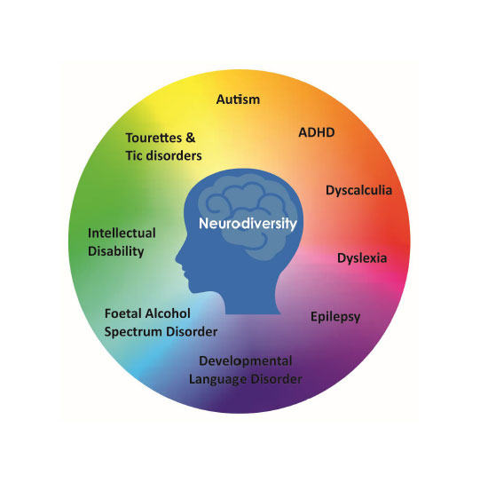
Neurodiversity

Being neurodivergent means having a brain that works differently from the average or “neurotypical” person. This may be differences in social preferences, ways of learning, ways of communicating and/or ways of perceiving the environment.

