Phonics Progression in Nursery at Ashfield Primary School

In Nursery we concentrate on developing children's speaking and listening skills and laying the foundations for the Read Write In work which starts in Reception. The emphasis during Nursery is getting children attuned to the sounds around them and ready to begin developing oral blending and segmenting skills.
Children in our Nursery class access a daily, formal phonics session. This is usually at the start of the day.
The session follows the following structure:
1 | Nursery Rhyme  The same nursery rhyme is repeated throughout the week to and revisited regularly throughout the year to ensure it is embedded in long term memory.
2 | Orientation, Turn Taking and Speaking/Listening  The children all take it in turn to say ‘good morning’ to Freddie the frog and tell him a positive affirmation about themselves.
3 | Teaching Point – See below for key focus per term.  Each session will focus on one (or more) of the following:  - Tuning into sounds (auditory discrimination)  - Listening and remembering sounds (auditory memory and sequencing)  - Talking about sounds (developing vocabulary and language comprehension).

In Nursery we focus on the following skills:
Autumn 1 | General sound discrimination – environmental sounds
Autumn 2 | General sound discrimination – instrumental sounds
Spring 1 | General sound discrimination – body percussion
Spring 2 | Rhythm and rhyme
Summer 1 | Voice sounds
Summer 2 | Oral blending and segmenting
Activities are designed to help children:
- Listen attentively.
- Enlarge their vocabulary.
- Speak confidently to adults and other children.
- Discriminate phonemes.
- Reproduce audibly the phonemes they hear, in order, all through the word.
- Use sound-talk to segment words into phonemes.

Sharing Books
Children benefit hugely by exposure to books from an early age. In Nursery, a wealth of opportunity is provided for children to engage with books that fire their imagination and interest. They are encouraged to choose and peruse books freely as well as sharing them when read by an adult. Enjoying and sharing books leads to children seeing them as a source of pleasure and interest and motivates them to value reading.
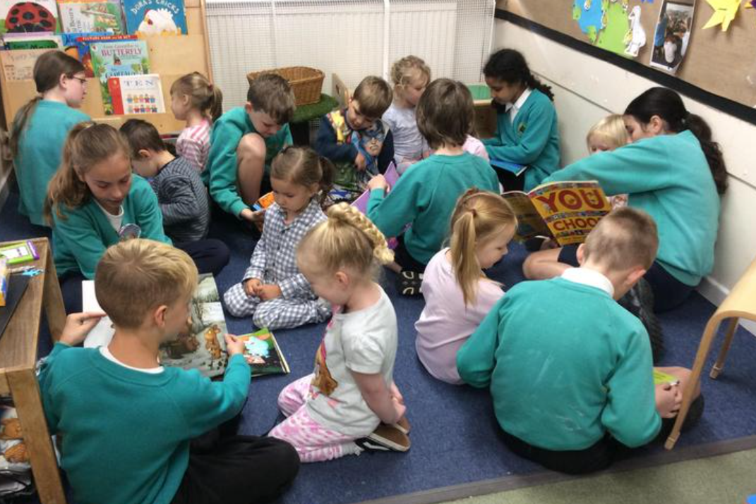
The children also get the opportunity to read with a buddy from another year group.

