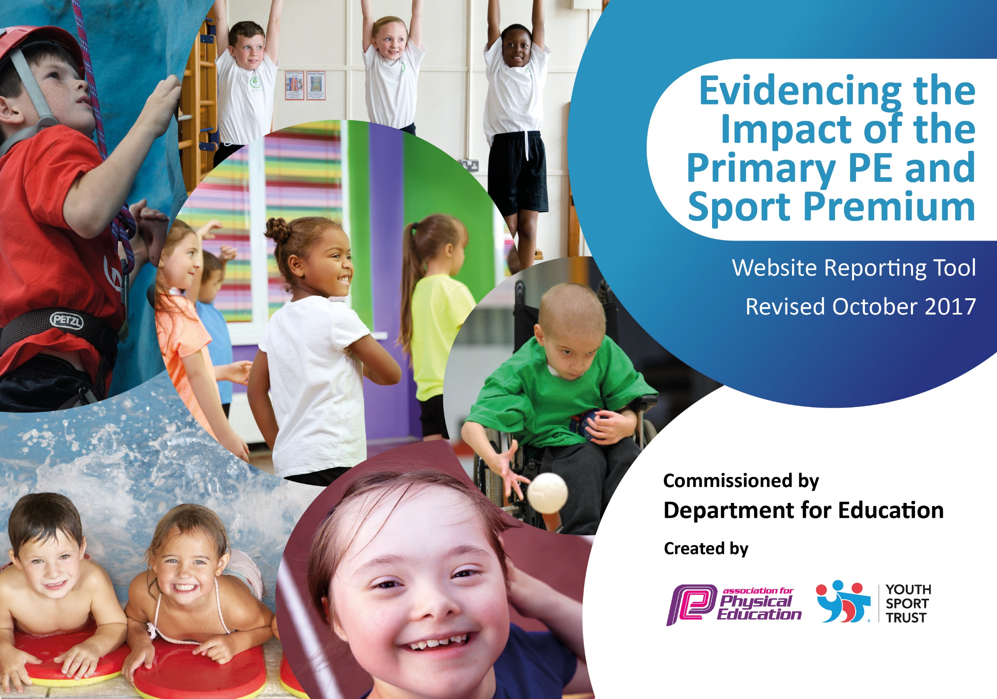

Schools must use the funding to make additional and sustainable improvements to the quality of PE and sport they offer. This means that you should use the Primary PE and Sport Premium to:

- develop or add to the PE and sport activities that your school already offers
- build capacity and capability within the school to ensure that improvements made now will benefit pupils joining the school in future years

Please visit gov.uk for the revised DfE guidance including the 5 key indicators across which schools should demonstrate an improvement. This document will help you to review your provision and to report your spend. DfE encourages schools to use this template as an effective way of meeting the reporting requirements of the Primary PE and Sport Premium.

We recommend you start by reflecting on the impact of current provision and reviewing the previous spend.
Under the Ofsted Schools Inspection Framework, inspectors will assess how effectively leaders use
the Primary PE and Sport Premium and measure its impact on outcomes for pupils, and how effectively governors hold them to account
for this.

Schools are required to publish details of how they spend this funding as well as on the impact it has on pupils’ PE
and sport participation and attainment.
We recommend regularly updating the table and
publishing it on your website as evidence
of your ongoing review into how you are using the money
to secure maximum, sustainable impact. To see an example of how to complete the table please click HERE.

Support for review and reflection - considering the 5 key indicators from DfE, what development needs are a priority for your setting and your students now and why? Use the space below to reflect on previous spend, identify current need and priorities for the future.

Key achievements to date: | Areas for further improvement and baseline evidence of need:
A few children are now competing at city and regional level  100% of children are now able to swim 25m by the end of Year 4  Silver Sainsbury’s Kitemark  Achieving 1st, 2nd or 3rd at many of the local competitions entered  Physical Activity Policy completed and presented to Governors  Participation monitored so we can look to target pupils next year | Physical Activity levels at times other than PE lessons  Improvement of outside space  Sports Council/Leaders  Teacher skills and confidence through CPD

Meeting national curriculum requirements for swimming and water safety | Please complete all of the below:
What percentage of your Year 6 pupils could swim competently, confidently and proficiently over a distance of at least 25 metres when they left your primary school at the end of last academic year? | 100%
What percentage of your Year 6 pupils could use a range of strokes effectively [for example, front crawl, backstroke and breaststroke] when they left your primary school at the end of last academic year? | 100%
What percentage of your Year 6 pupils could perform safe self-rescue in different water-based situations when they left your primary school at the end of last academic year? | 100%
Schools can choose to use the Primary PE and Sport Premium to provide additional provision for swimming but this must be for activity over and above the national curriculum requirements. Have you used it in this way? | Yes

